**GROUP CASE 2: FORECASTING AND REGRESSION ANALYSIS OF CRUSTY PIZZA RESTAURANTS ON MONTHLY PROFITS**

**By**

Taylor Millwood

Steven Faurot Jr

Jacob Malarik

Pradeepika Ravala

**MBA 624: BUSINESS ANALYSIS FOR DECISION MAKING**

**PROFESSOR: IVANA SAVIC**

**BELLEVUE UNIVERSITY**

**AUGUST 4, 2019**

**ABSTRACT**

Crusty Pizza Restaurant has approximately 60 stores across various locations that offer wide varieties of pizzas to customers. The management of the company has provided us with the primary data available on all 60 stores and wanted to identify and analyze which factors have a greater influence on the success and unsuccess of the store. In the document presented through this case, we use different regression and forecasting analysis to predict the factors influence as well as monthly profit.

**TABLE OF CONTENTS**

|  |  |  |
| --- | --- | --- |
| 1 | Project Overview | 3 |
| 1.1 | Purpose and Objective |  |
| 1.2 | Methods of calculation |  |
| 2 | Company Background | 3 |
| 3 | Key Variables | 4 |
| 4 | Key Findings | 4-8 |
| 4.1 | Simple regression analysis | 4 |
| 4.2 | Goodness of fit and F-test | 5 |
| 4.3 | Monthly profit Prediction | 6 |
| 4.4 | Ranking orders of stores | 7 |
| 5 | Conclusion | 8 |
|  | LIST OF TABLES |  |
|  | Table 1: Correlation coefficients of all variables | 4 |
|  | Table 2: Regression, slope and intercept of key variables | 5 |
|  | Table 3: Goodness of fit and p-value significance | 6 |
|  | Table 4: Ranking of new stores | 7 |
|  | ANNEXURE - I: REGRESSION STATISTICS OF ALL VARIABLES | 11 |
|  | ANNEXURE - II: SCATTER PLOTS OF VARIABLES | 13 |
|  | ANNEXURE - III: REGRESSION FOR FORECASTING | 16 |

**OVERVIEW**

The report presented below depicts the forecasting statistics of monthly profit and regression statistics of various variables for Crusty Pizza Dough Company. This is a successor of the previous case “Descriptive statistics of stores and the contribution of factors on its success”, which used various techniques of graphs, mean, median and mode to determine the factors contribution on monthly profits. In this case we use regression analysis and forecast analysis to determine the monthly profit based on the key variables identified in the previous case.

**PURPOSE AND OBJECTIVE:**

The main objective of this analysis is to predict the monthly profit for each store. The purpose of this analysis provides the management with sufficient knowledge on the key variables and the monthly profit forecast to determine the decision on opening new stores.

**METHODS OF CALCULATION:**

The key variables were identified from previous analysis. The methods of calculation used for this analysis are simple linear regression, where each variable is considered as Independent variable and the monthly profit as dependent variable. F-test analysis on p-values are calculated. Forecasting with regression analysis on monthly profit is calculated. The coefficient of determination (R^2) is also calculated. Based on all results, the top five and bottom five locations to establish new stores are identified.

**COMPANY BACKGROUND**

The Crusty Dough Pizza company has 60 stores. Data on monthly profit and various factors related to all stores are collected and presented to us for a brief analysis of their importance, impact and influence on the success of the company. On an average, 23% of stores have buffet provision, 73% of stores offer pizza slices, 80% of stores have positive reviews, 78% of stores have delivery options, 50% stores have liquor license, 67% stores have seating arrangements. On an average the company makes $14000 monthly profit combined from all stores and an average of $1700 is spent on monthly advertising expenses. The average population within 20 miles is around 300000, where as student population constitute 12000.

**KEY VARIABLES**

|  |  |  |  |  |  |
| --- | --- | --- | --- | --- | --- |
| **S.No** | **Variable** | **Correlation Coefficient** | **S.No** | **Variable** | **Correlation Coefficient** |
| 1 | Advertising Expenses | 0.77 | 9 | Competitors within 15 miles | -0.16 |
| 2 | Student population | 0.50 | 10 | Order Options | 0.16 |
| 3 | Store Size | 0.41 | 11 | Buffet option | 0.13 |
| 4 | Delivery option | 0.39 | 12 | Liquor license | 0.06 |
| 5 | Seating | 0.38 | 13 | Review | 0.06 |
| 6 | Parking | 0.37 | 14 | Population within 20 miles | 0.04 |
| 7 | Competitors within 2miles | -0.21 | 15 | Pizza varieties | 0.02 |
| 8 | Competitors within 5 miles | -0.16 | 16 | Pizza slice offer | 0.02 |

**Table 1: Correlation coefficients of all variables**

Based on the above table, the key variables that have high influence and will be dealing with the regression analysis and forecasting of monthly profits include Advertising expenses, store size, student population, delivery options and competitors within 2 miles.

**KEY FINDINGS**

**4.1 Simple Regression Analysis:**

As we started our analysis in Case 1 we use measures such as mean, median, mode, range, and standard deviation to identify factors that really affected our profits at each of the original 60 locations. From this data we identified the biggest influencers in a location’s success. The following factors are the identifiers that we have performed a simple regression analysis to determine if these are in fact true indicators of success. Please refer to ANNEXURE I and II.

|  |  |  |  |
| --- | --- | --- | --- |
| **Variable** | **R** | **Slope** | **Intercept** |
| Advertising Expenses | .5976 | 12.586 | -8126.4 |
| Student Population | .2469 | .9001 | 2790.1 |
| Store Size | .1716 | 3581.7 | 3668.6 |
| Delivery Options | .1524 | 8721.4 | -1139.4 |
| Competitors within 2 miles | .0464 | -1405.1 | 18489 |

**Table 2: Regression, slope and intercept of key variables**

Upon first evaluation of the regression analysis you will note that all of the factors that we have identified do show strong correlations in relation to profit. The only factor that reflects a negative correlation is competition within 2 miles. This is exactly what we expected to find. Given the more competition directly around you, you will suffer some business loss to the increase in possible choices for a consumer.

Now that we have confirmation that our initial suspicions were correct in Case 1 and our regression analysis supports this. We can take this data to help formulate a forecast for the possible locations with special considerations focused on these factors.

**4.2 Goodness of Fit and p-values:**

Coefficient of determination $({R² or r²)}^{}$ measures the percentage of the total variation of our dependent variable that is explained by our independent variable. Higher the value, the higher the dependency.

|  |  |  |  |  |
| --- | --- | --- | --- | --- |
| **Variables** | **Coefficient of Determination** | **P-value (from F-Test)** | **95% CI Values** | **Standard error** |
| Advertising Expenses | 0.5976 | 0.00 | 9.87 - 15.30 | 5938.57 |
| Student population | 0.2469 | 0.0001 | 049 - 1.31 | 8124.06 |
| Store Size | 0.1716 | 0.0010 | 1513.40 - 5649.96 | 8520.42 |
| Delivery option | 0.1524 | 0.0020 | 3315.02 - 14127.7 | 8618.77 |
| Competitors within 2miles | 0.0464 | 0.0984 | -3079.83 - 269.55 | 9141.84 |

**Table 3: Goodness of fit and p-value significance**

In the above table almost all the variables have higher coefficient of determination values compared to rest of independent variables. The p-value obtained from the top five variables are less than $α=0.05$. Hence we can reject the null hypothesis which stated that there was no linear relationship between the monthly profit and the respective variables of monthly advertising expenses, delivery, store size and student population. For the independent variable if $α=0.10$, the p value is less indicating that a linear relationship exists rejecting the null hypothesis.

**4.3 Monthly profit prediction**

We achieved the monthly profit forecast by finding the multiple regression of the top correlations of the independent variables in Case 1. Using the monthly profit as the dependent variable, we calculated the regression equation coefficients from Case 1. Then, we used these values to calculate the monthly profit in the Case 2 file. For example, monthly advertising regression equation coefficient was determined to be 3.7019, then this value was multiplied by each of the monthly advertising expenditures for each of the Case 2 stores. This same activity was done for each of the following regression equation coefficients: (monthly advertising expenditures, student population, store size, competitors within 2 miles, delivery). These values were then added together plus the intercept value (-5,157.28) to find the forecasted monthly profits for each store in Case 2.

**4.4 Ranking orders of stores:**

|  |  |  |  |  |  |  |  |
| --- | --- | --- | --- | --- | --- | --- | --- |
| **Store** | **Monthly Advertising Expenditure** | **Student Population** | **Store Size** | **Competitors within 2 miles** | **Delivery options** | **Monthly Profit** | **Store Ranking** |
| I | 3039 | 20416 | 4 | 3 | 2.00 | 32,353.51 | **1** |
| N | 2349 | 18207 | 4 | 3 | 2.00 | 25,614.78 | **2** |
| E | 2398 | 18130 | 4 | 3 | 1.00 | 22,200.17 | **3** |
| F | 1926 | 13637 | 3 | 2 | 2.00 | 21,446.65 | **4** |
| H | 1924 | 21302 | 4 | 5 | 2.00 | 20,093.46 | **5** |
| J | 2319 | 16161 | 4 | 3 | 1.00 | 18,177.92 | **6** |
| R | 1966 | 14328 | 3 | 3 | 2.00 | 17,998.27 | **7** |
| L | 1812 | 18659 | 4 | 5 | 2.00 | 14,672.31 | **8** |
| A | 1885 | 6621 | 2 | 1 | 1.00 | 10,609.12 | **9** |
| Q | 1246 | 4165 | 1 | 1 | 2 | 8,190.61 | **10** |
| C | 1015 | 8221 | 2 | 2 | 1.00 | 5,513.92 | **11** |
| M | 1293 | 10614 | 3 | 3 | 1.00 | 5,021.48 | **12** |
| S | 1149 | 9987 | 2 | 4 | 2.00 | 2,994.61 | **13** |
| T | 1125 | 3344 | 1 | 1 | 1.00 | 2,737.35 | **14** |
| K | 1192 | 10188 | 3 | 4 | 2.00 | 2,385.39 | **15** |
| O | 1036 | 15377 | 4 | 5 | 1.00 | 2,132.54 | **16** |
| P | 921 | 6523 | 2 | 3 | 2.00 | 494.25 | **17** |
| D | 987 | 8758 | 2 | 4 | 2.00 | 66.86 | **18** |
| G | 1228 | 6624 | 2 | 3 | 1.00 | -1,628.10 | **19** |
| B | 923 | 8429 | 2 | 4 | 1.00 | -4,243.42 | **20** |

**Table 4: Ranking of new stores**

The table above shows the stores ranked by highest to lowest forecasted monthly profit. As you can see, the top 5 stores are I, N, E, F, and H and the bottom 5 stores are O, P, D, G, and B. It is recommended that the Crusty Pizza Company open the top 5 stores because all 5 are predicted to have an over $20,000 monthly profit. The company should definitely stay away from opening a store at the bottom 5 ranked locations to avoid making very little profit to a total loss of profit.

**Conclusion**

In our previous analysis through excel calculations and descriptive statistics, we have found the highest contributing factors to the success and unsuccess of the 60 Crusty Pizza stores. The 5 factors with the greatest influence to the monthly profit of these stores are student population, monthly advertising expenses, store size, competitors within 2 miles and delivery. Through our analysis, we were able to reveal that stores will find themselves more profitable if they have a bigger store size, which also allows for a dine-in option or seating at the store, if they spend more than $1,000 on monthly advertisement preferably between $2,000 and $3,000, and if you are in a higher populated area with less competition. Our main objective in this part of the case was to forecast a monthly profit for each store to help the Crusty Pizza Company executives identify the top 5 and bottom 5 locations. After choosing which variables would be good indicators of profit by f-test analysis on p-value calculations and performing simple linear regression analysis we were able to forecast the monthly profit of each store and then rank them in order from highest to lowest monthly profit. Our recommendation to the Crusty Pizza executives are to open stores I, N, E, F, and H because they were identified as having the highest forecasted monthly profit, each above $20,000. Because these stores spent around $2000-$3000 on monthly advertising, the store size is very large, an average of 18000 student population, the competitors are less and the stores have delivery option. Where as if we look at the least profiting stores (O, P, D, G, B), we find that amount spent on advertising ranges between 900-1000, the student population is on an average of 9000, the store size is small and competition is high, which had a greater impact on profit. It is therefore concluded that the independent variables of monthly advertising expenses, store size, student population, delivery option and competition plays a very critical role in the profit of the organization on a whole.

**References:**

Donnelly, R. A. (2015). *Business Analysis for Decision Making* (1st custom ed.). Boston, MA: Pearson Education. Retrieved from<https://etext.pearson.com/eplayer/> (E-book series)

**ANNEXURE - I**

**SIMPLE REGRESSION ANALYSIS**

**Monthly profit Vs Advertising expenses**

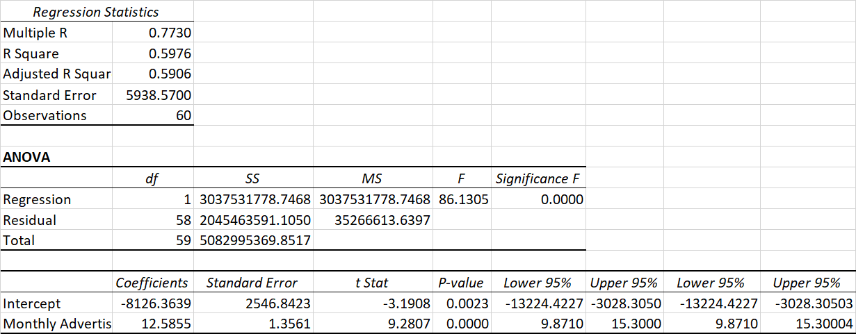

**Monthly profit Vs Student Population**

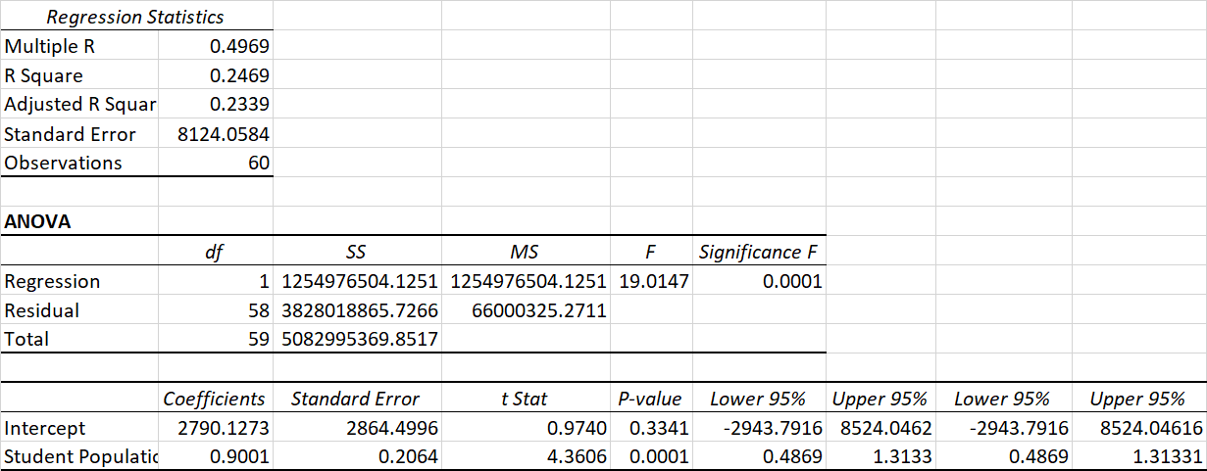

**Monthly profit Vs Store size**

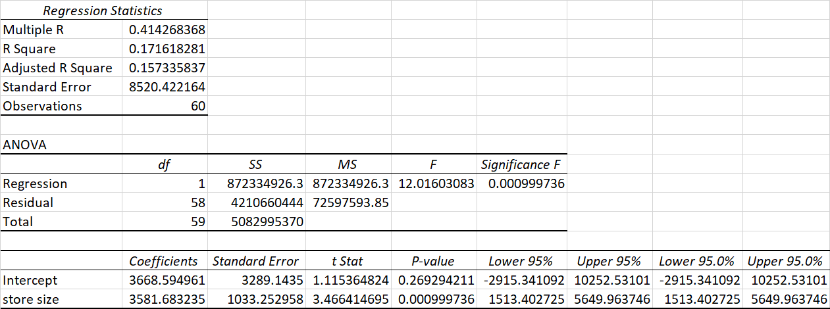

**Monthly profit Vs Delivery option**

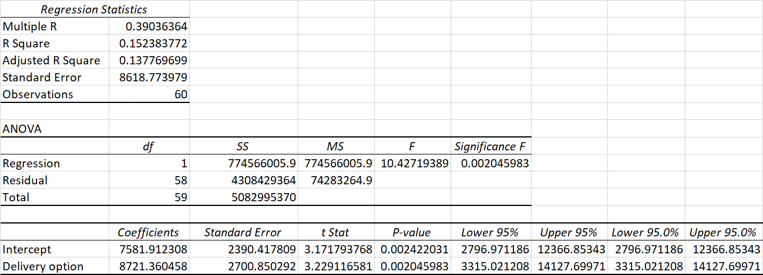

**Monthly profit Vs Competitors within 2 miles**

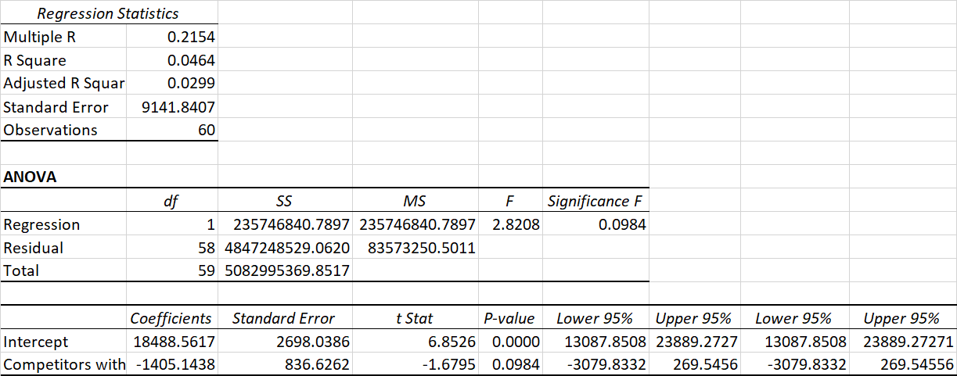

**ANNEXURE - II**

**SCATTER PLOTS OF VARIABLES**

**Monthly profit variation with respect to store size**

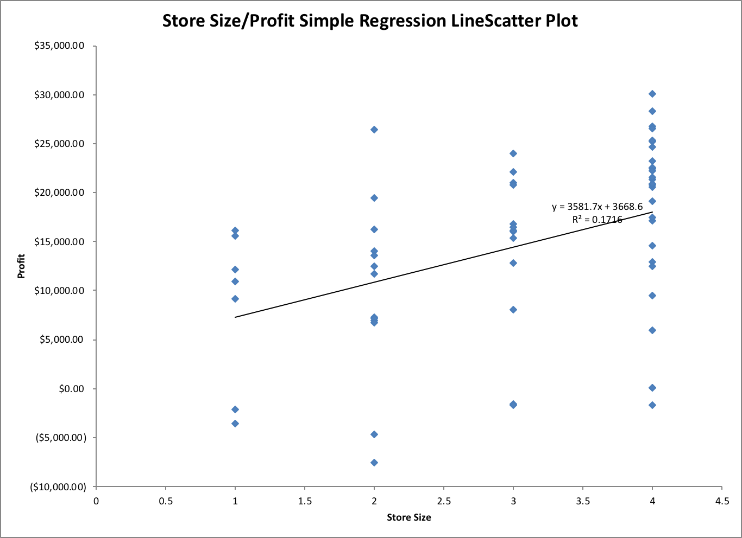

**Monthly profit variation with respect to monthly advertising expenses**

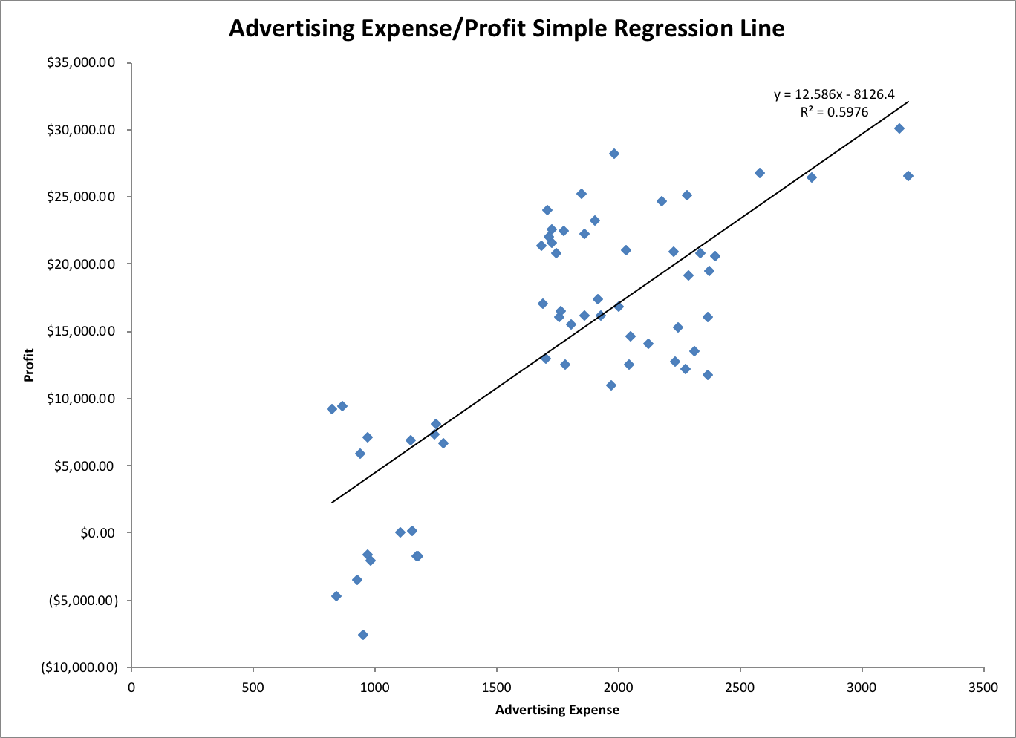

**Monthly profit variation with respect to competition within 2 miles**

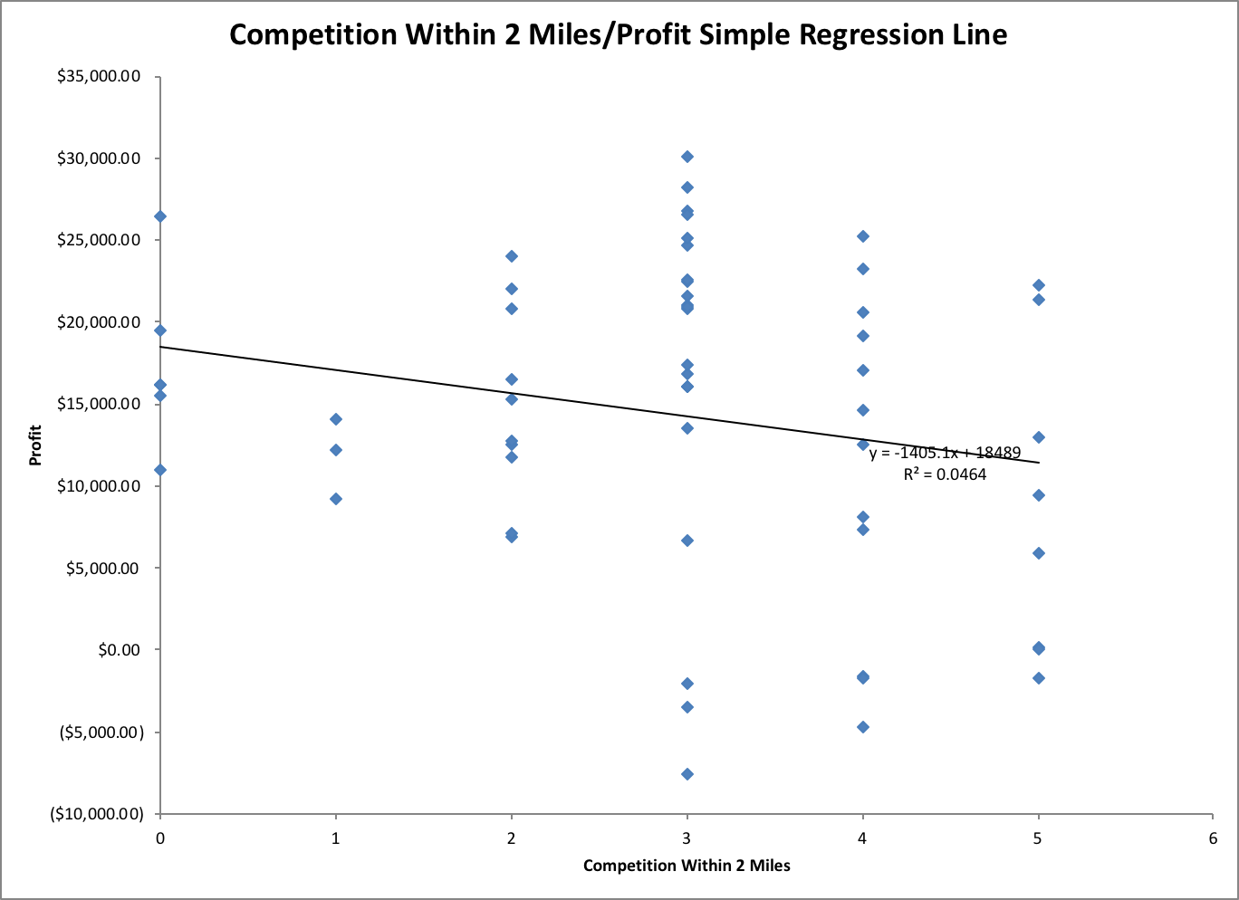

**Monthly profit variation with respect to student population**

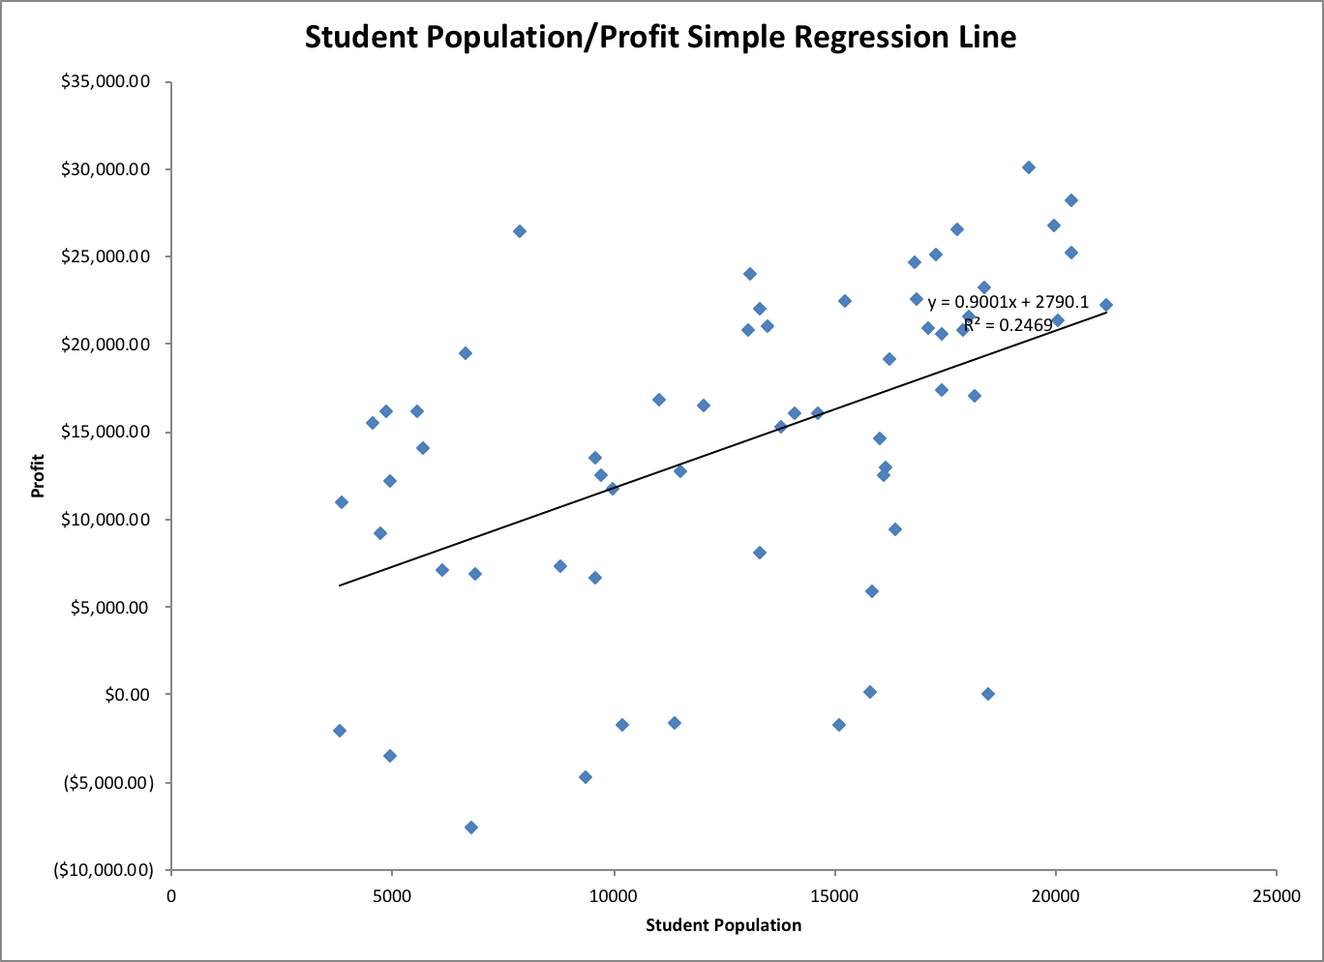

**Monthly profit variation with respect to Delivery**

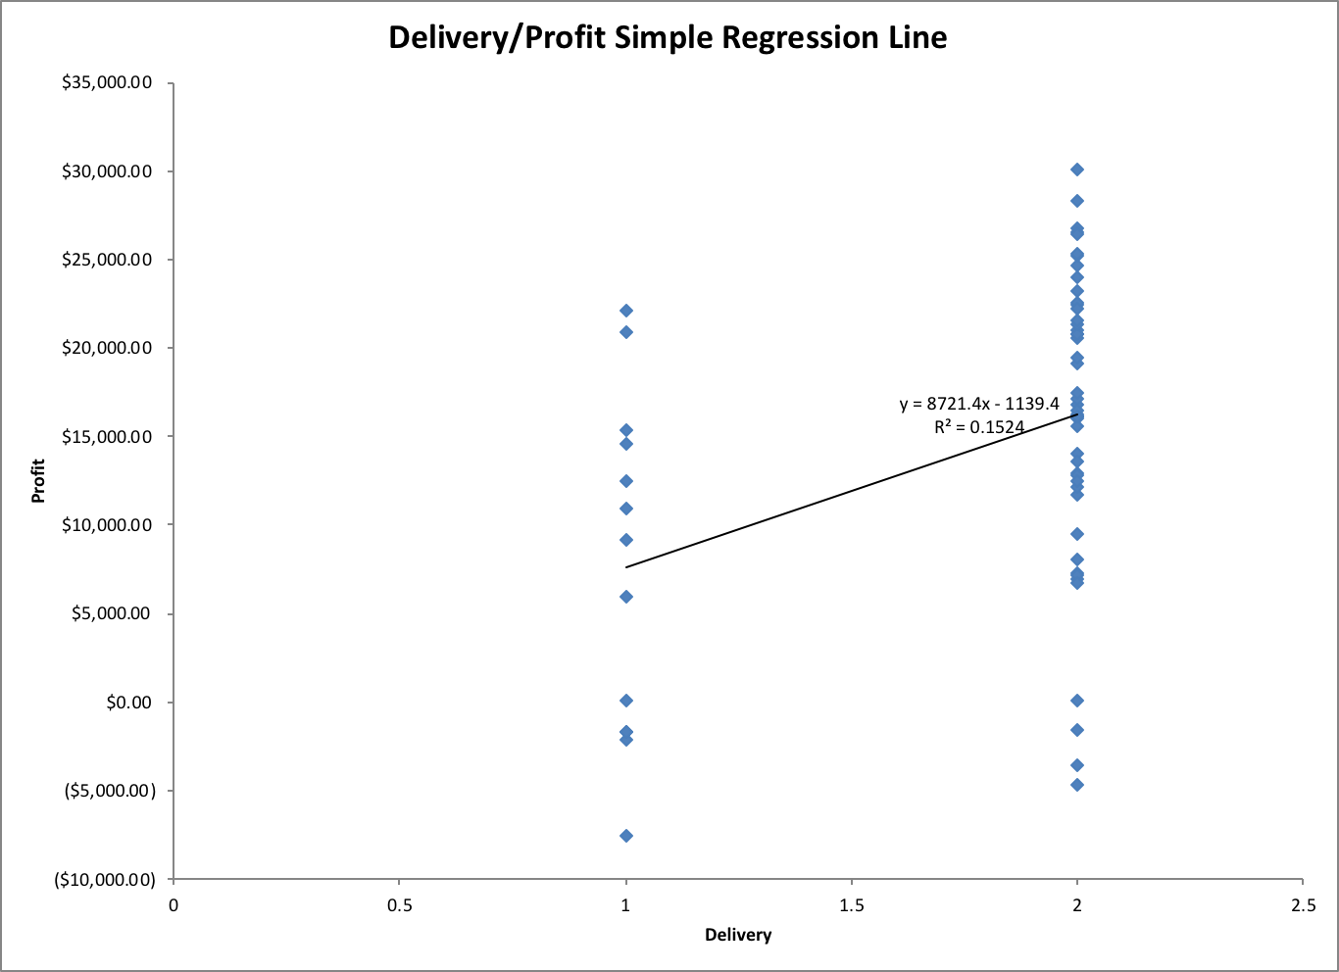

**ANNEXURE - III**

**REGRESSION ANALYSIS FOR FORECASTING**

**Multiple regression analysis for key variables.**

